- What kinds of sport are popular in Ukraine?
In my opinion, football and swimming are popular in Ukraine
I think hockey is
I guess tennis and gymnastics are
I believe basketball is
To my mind, skating and skiing are
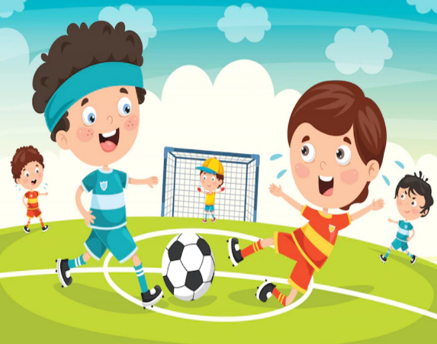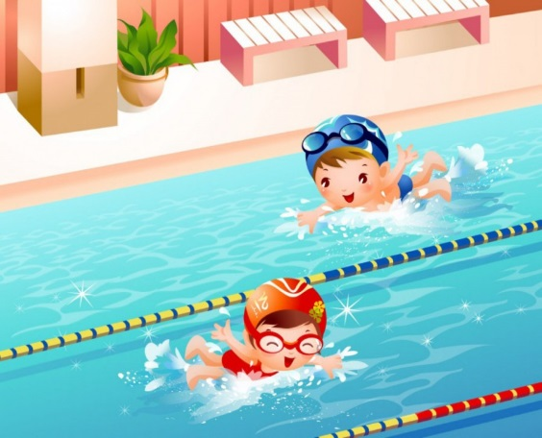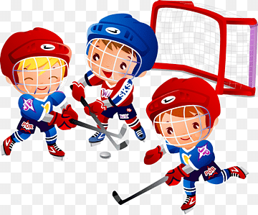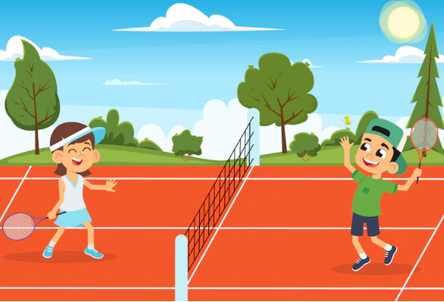
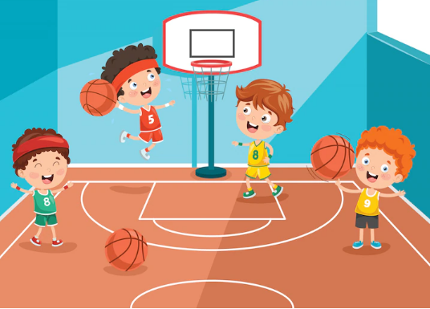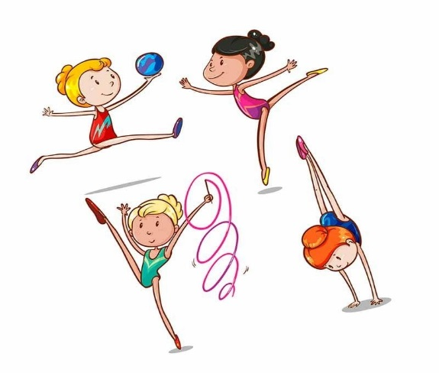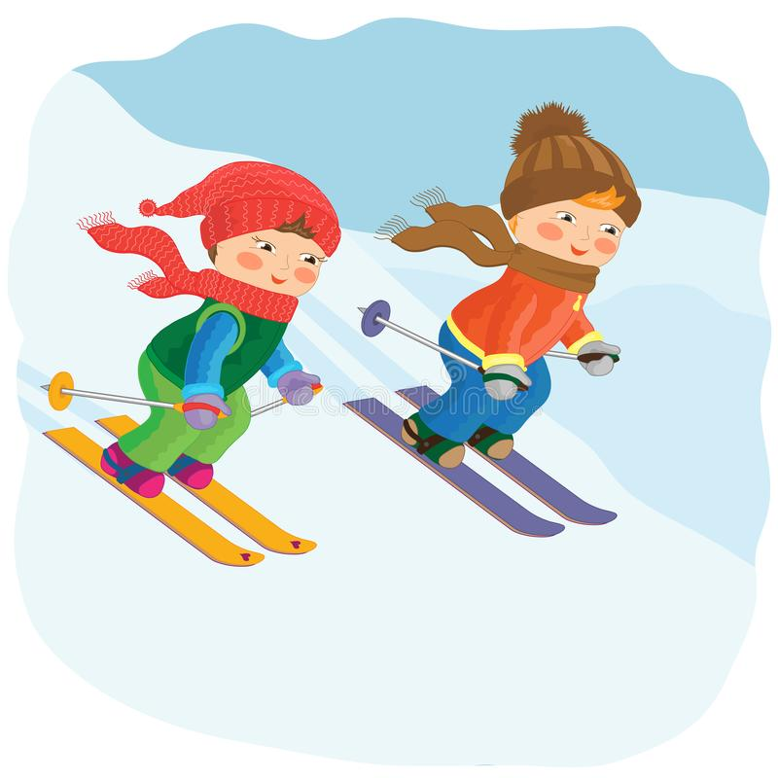

- What is your favourite sport?
My favourite sport is football
tennis
basketball
swimming
skating
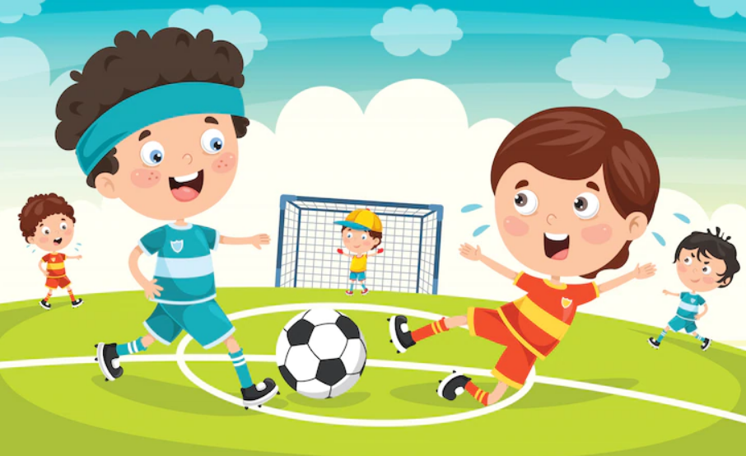
- What sport are you fond of?
I am fond of skiing
hockey
rowing
karate
boxing

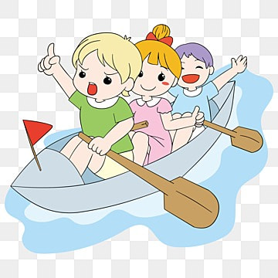
- What sport is your friend interested in?
He/ She is interested in gymnastics
running
horse riding
skateboarding
cycling
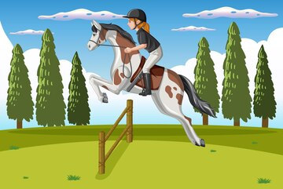
- What sport is your sister/ brother crazy about?
He/ She is crazy about rollerblading
aerobics
cricket
judo
badminton
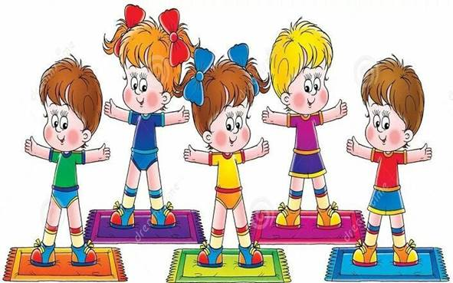
6. What games do you like to play?
I like to play chess
football
tennis
basketball
volleyball
hockey
