- What do you do to help about the house?

I usually wash the floor every day
always cook meals once a week
sometimes do the washing-up on weekdays
never water the plants at the weekend
seldom throw away rubbish
often feed the pet
walk a dog
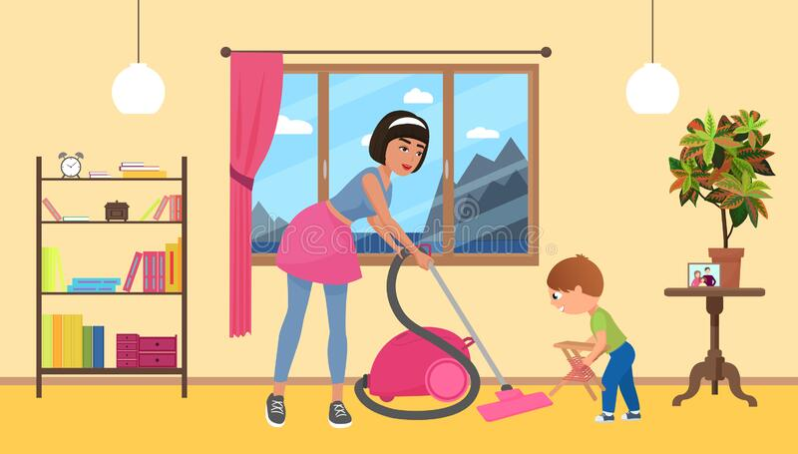

- What householding duties does your mother
( father/ grandmother/grandfather/sister/brother) have?
My mother cook meals
My father fix things
My grandmother has to wash the dishes
My grandfather do the hovering
My sister dust the furniture
Mybrother throw away rubbish
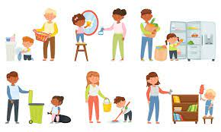
- What do you like doing about the house?

I like doing the laundry
sweeping the floor
going shopping
tidying the room
making a bed


4.What don’t you like doing about the house?

I don’t like fixing things
doing the ironing
doing the hovering
making a bed
dusting the furniture
throwing away rubbish
washing the dishes