- You can cook breakfast with your mum
You can wash the dishes with your mum
There are so many things ( 2 times)
That you can do with your mum.
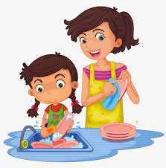

- You can fix things with your dad
You can mop the floor with your dad
There are so many things ( 2 times)
That you can do with your dad.
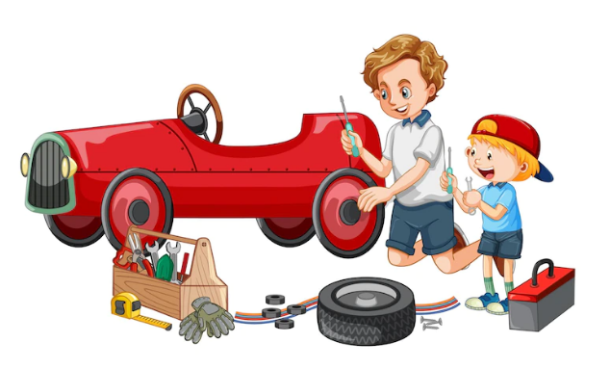

- You can clean the flat with your parents.
You can walk the dog with your parents.
There are so many things ( 2 times)
That you can do with your parents.
