**Make up sentences** 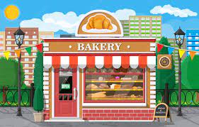

**a loaf of bread at the chemist’s**

**a tube of toothpaste at the grocery**

**a packet of butter at the sweet shop**

**We can buy a bottle of oil at the butcher’s**

**a box of sweets at the bakery**

**a tin of fish at the dairy**

**a kilo of cheese at the greengrocery**

**a lemon and some onions at the florist’s**

**a packet of sugar at the toy shop**

**a kilo of meat at the fishmonger’s**

**a carton of milk**

**some medicine**

**roses and tulips**

**dolls and toy cars**

**a loaf of bread florist’s**

**a tin of fish chemist’s/ drug store/pharmacy**

**a tube of toothpaste bakery/ baker’s**

**a cake fishmonger’s**

**some flowers sweet shop/ candy shop/ confectionery**

**a toy train butcher’s**

**I can buy a sweater at the grocery/ grocer’s**

**some meat toy shop**

**a magazine clothes shop**

**vegetables and fruits shoe shop**

**some medicine book shop**

**shoes and boots newsagent’s**

**a ring greengrocery/ greengrocer’s**

**a bottle of oil jewelry**

**a book about Harry Potter supermarket**

**a bike furniture shop**

**a table sporting goods/ sports goods**

**a guitar dairy**

**a bottle of milk music shop/ record shop**