1

Shop assistant: Good morning! Can I help you?

Customer: I need a kilo of meat. Do you have any meat?

Shop assistant: Yes, we’ve got a lot. Anything else?

Customer: Yes, I’d like to buy some sausages.

Shop assistant: How many would you like?

Customer: About a half of a kilo, I think. And that’s all. How much does it cost?

Shop assistant: 35 pounds for meat and 15 pounds for sausages. 50 pounds for all.

Customer: Ok. Thanks a lot. Good-bye.

Shop assistant: Good bye! Have a nice day!

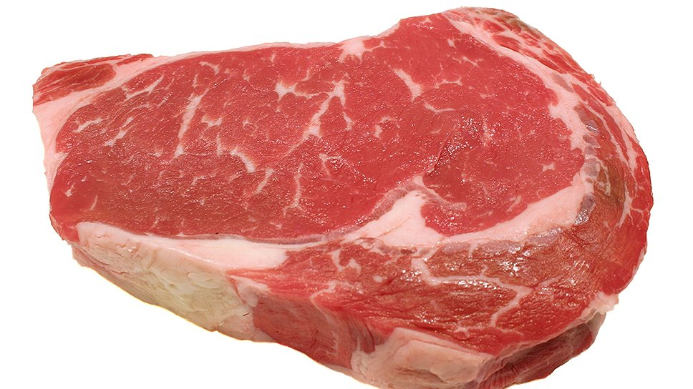 

2

Shop assistant: Good morning! Can I help you?

Customer: Yes. I’d like to buy a dozen of roses to my wife. She’s got her birthday tomorrow.

Shop assistant: Ok. What colour would you like?

Customer: She likes red. So, I’ll take red roses. Could you send them tomorrow at 10 am in Forest street, 15?

Shop assistant: Sure.

Customer: Great! How much are they?

Shop assistant: 20 pounds, sir.

Customer: Here you are.

Shop assistant: Ok. Good-bye and thank you! Have a great day!

Customer: Bye!

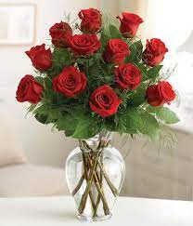

3

Shop assistant: Hello! Could I help you?

Customer: I’d like a big birthday cake and a box of chocolate sweets. Are there any?

Shop assistant: Yes. We’ve got chocolate cakes and strawberry ones. And we have two boxes of chocolate sweets. They are on sale now. What would you like to buy?

Customer: I’ll take a chocolate cake and these two boxes of sweets. How much I need to pay?

Shop assistant: Please, wait a minute….45 pounds.

Customer: Oh, it’s a great bargain. Here you are. Thanks!

Shop assistant: You are welcome!

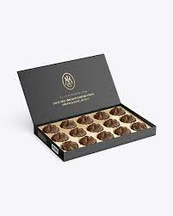  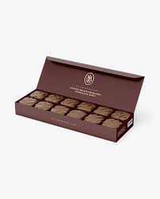

4

Customer: Good afternoon!

Shop assistant: Hello! Can I help you?

Customer: Yes, I’m looking for a dress.

Shop assistant: Ok. There is a big variety of dresses. What size are you and what colour would you like?

Customer: I think, size 10 will fit me well. I want it in a light green colour.

Shop assistant: Ok….What about this one?

Customer: Yes, it’s nice. I’ll take it. How much is it?

Shop assistant: 40 pounds.

Customer: It’s OK with me.

Shop assistant: Here you are! Thanks a lot! Good-bye! Have a great day!

Customer: Thanks! Good-bye!

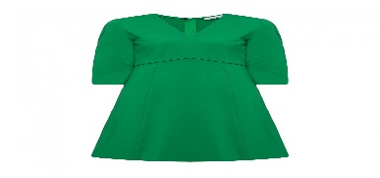

5

Shop assistant: Hello! How can I help you?

Customer: I need five bananas, a kilo of potatoes and three oranges, please.

Shop assistant: Here you are! They are 35 pounds.

Customer: Thanks!

Shop assistant: Anything else?

Customer: No, I think that’s all. Good-bye!

Shop assistant: Good-bye! Have a nice day!

