Choose the correct words
- Tina is in her mid twenties/teens. She is thin/ plump. She’s got fair/dark hair. Her hair is curly/straight. She is fat/thin.

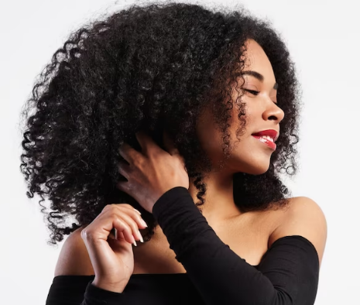

- Mary is his/her early thirties. She’s short/ of medium height. She’s slim/fat. She’s got wavy/straight hair.

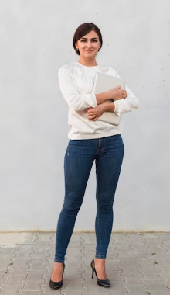

- Mr Chen is in his late/ teens sixties. He is tall/ short. He’s got short/long hair. His hair is red/grey. He is thin/ plump.
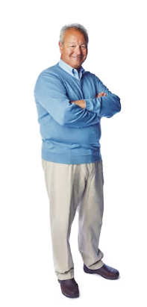

- Meg is a middle-aged/teenager. She’s short/ tall and she’s thin/fat. She’s got short/long hair. Her hair is blond/brown.
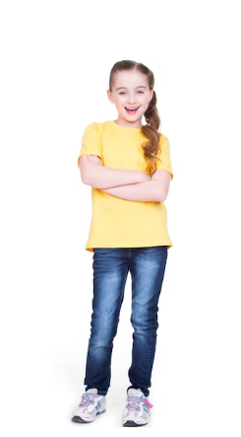

- Mrs Taylor is young/elderly. She is slim/ plump. She’s got short/long hair. Her hair is blond/grey. She is wearing glasses.
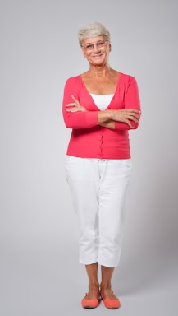

- Nick is young/ middle-aged. He’s short/tall with short wavy/straight hair. His hair is fair/red. He’s got freckles/ glasses, too.
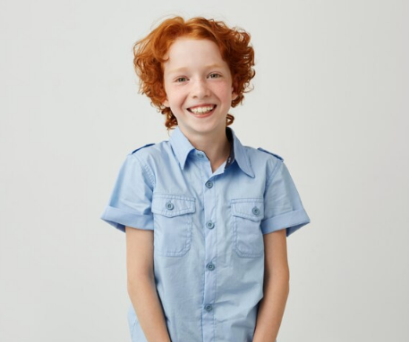

- Max is in his late thirties/seventies. He is tall/short. He is well-build /overweight. He has got dark /grey hair. He’s got a beard and glasses/a moustache.


Match the words with their opposites
Straight Young
Dark (hair) Plump
Elderly Curly
Short (hair) Dark
Well-build Fair
Pale (complexion) Long

